**Git Practical Exam Assignment**

U,{74c1aab7-cd7c-4c38-85ac-bb190ab196fa}{33},0.6666666666666666,0.6666666666666666

Create one repository for practical and provide the link of it for review.

Work on below points:

1. Pull and Merge difference

- Make example of pull request and two branch merge event.

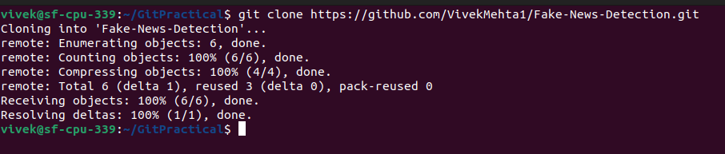

|  |
| --- |
| Cloning an existing repository |

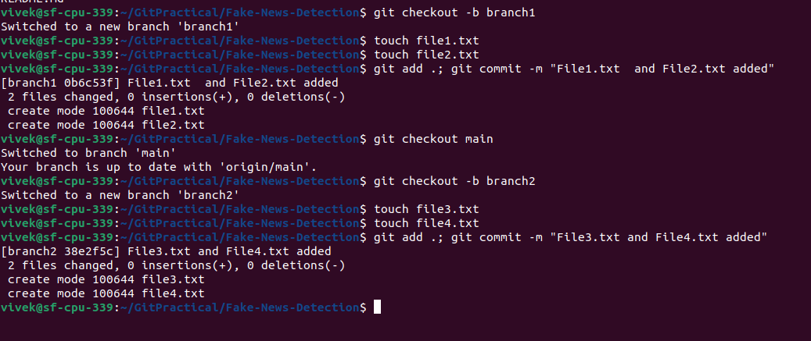

Creating 2 branches

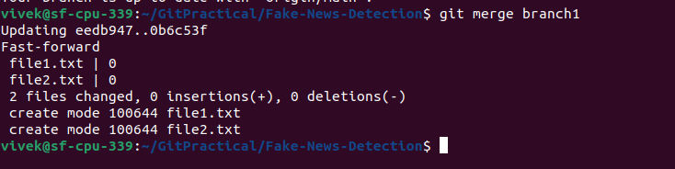

Merging branch1 in main

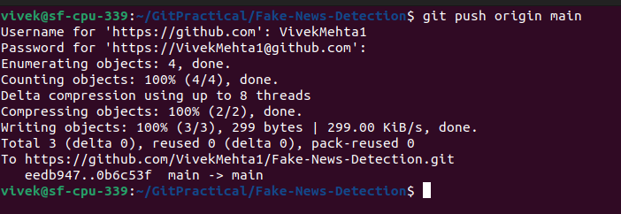

Pushing the main branch to GitHub repo

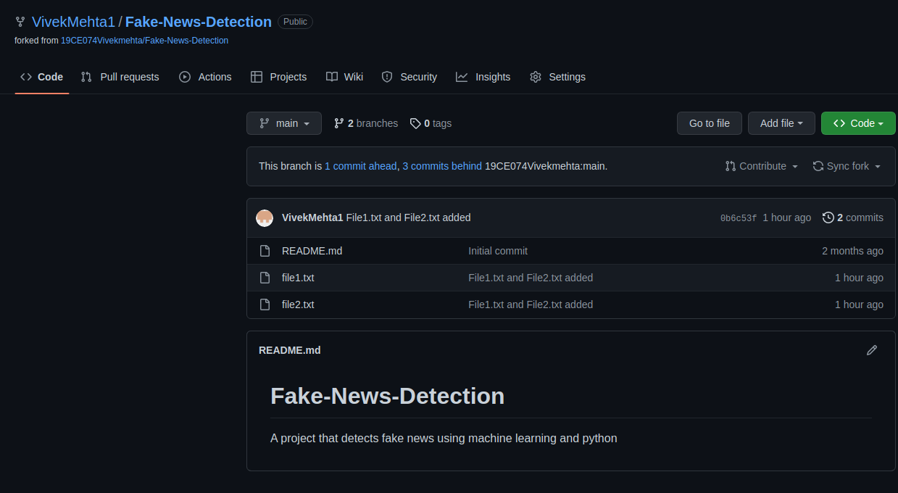

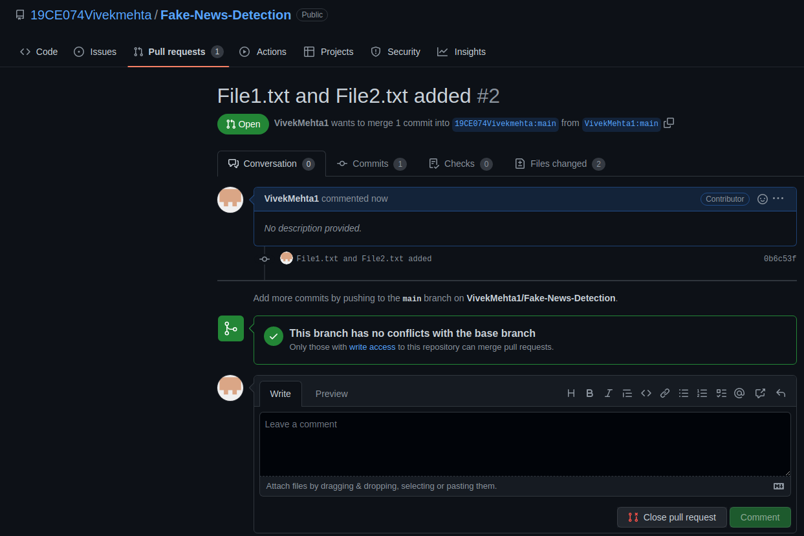

Creating a pull request.

2. Rebase

- Try to rebase feature branch with master branch

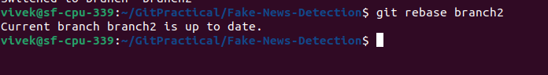

3. Change commit message

- Commit push on commit in feature branch and then change commit message

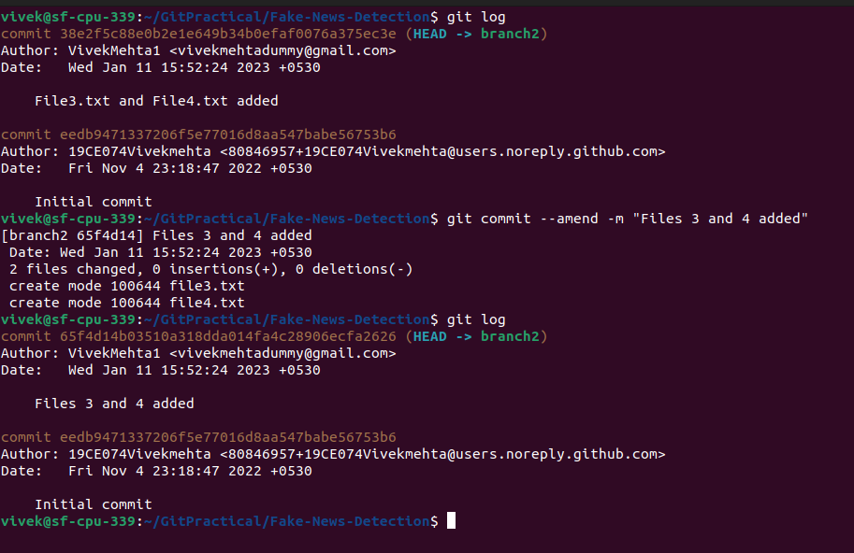

4. cherry pick

- Pick some commits from feature branch to master branch

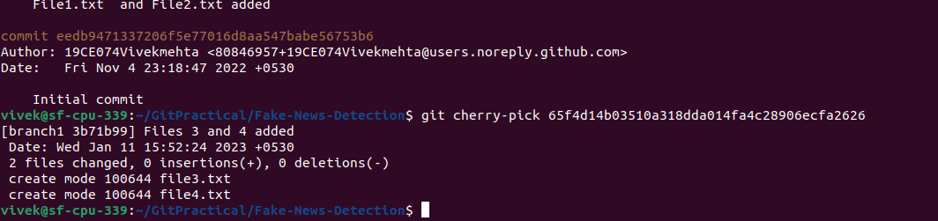

5. Drop commit

- Remove some commit from feature branch**.**

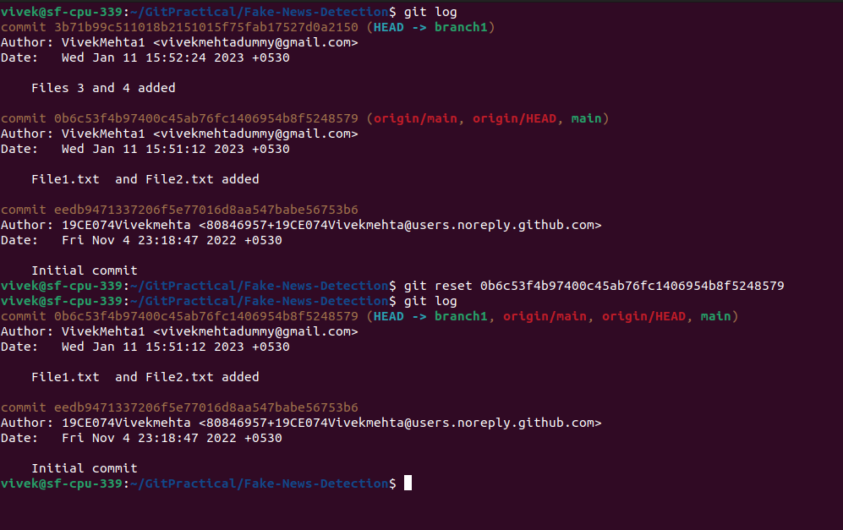

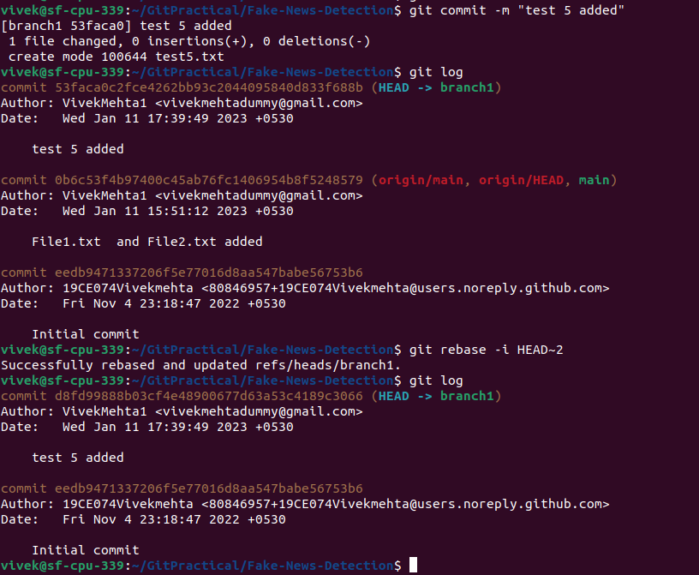

To drop a particular commit